JSON_SIMPLE AND NESTED

To Create a Table
Steps:
Step-1 Snowsql -v
Step-2 Snowsql -a ___ -u__ -p____
Step-3 Create database emp_json
Step-4 Create schema emp_schema
Step-5 Create table employees_json(raw variant);

Output:
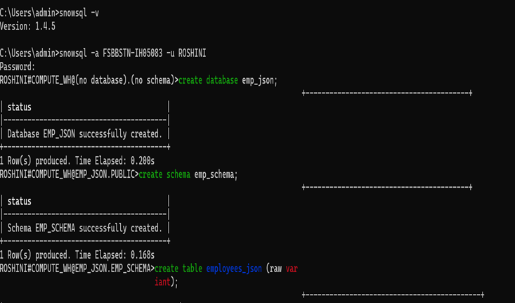
Output for Creating New Table

Step-6 Create stage emp_stage;
Step-7 Put 'file://C:/Users/admin/Downloads/employees.json' @emp_stage;
Step-8 create or replace file format ff_json_flat type = 'JSON' strip_outer_array = false;
Step-9 copy into employees_json from @emp_stage/employees.json file_format =
(format_name= ff_json_flat);

Output:

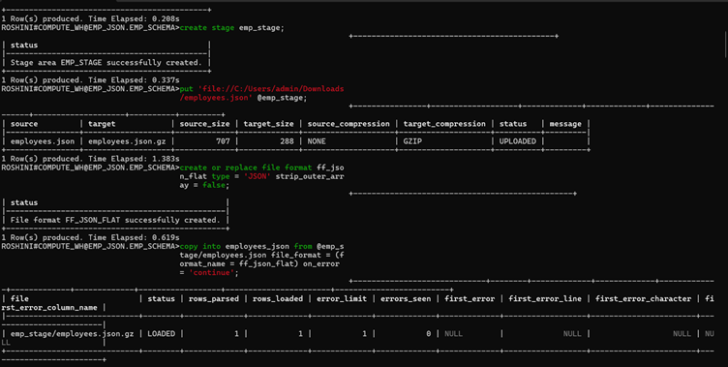

Output for Copy the data to snowflake

Step-10 select * from employees_json;

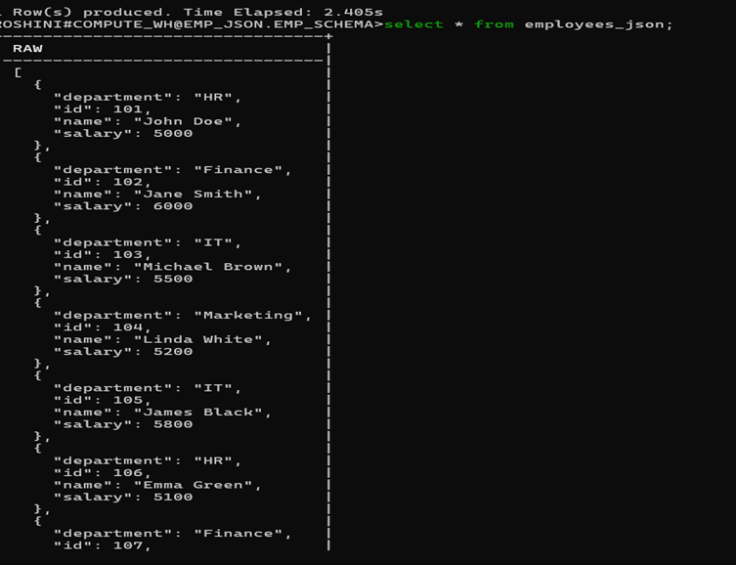

Output for normal json

In this result i got this output but i want in j_son method so i modify the select query into Json_simple.

Select Value:ID::Int As ID,
Value:Name:: String As Name,
Value:Department:: String As Department,
Value:Salary:: Int As Salary
from Employee.json,
Lateral Flatten,(input=>raw);

Output:

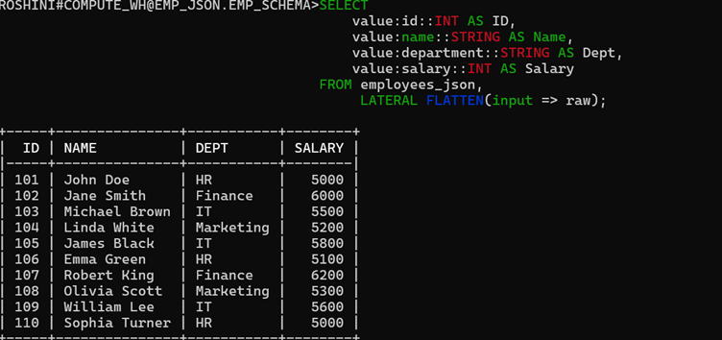
Output for select in json_simple
These are the step for select query:
Step-1 The Table (Employee.json) contains JSON data.
Step-2 FLATTEN(input => raw) breaks the JSON array into separate rows.
Step-3 value:ID, value:Name, etc., extract fields from the JSON.
Step-4 ::INT or ::STRING converts them into proper data types.
Step-5 The query returns clean columns like ID, Name, Department, Salary
LATERAL FLATTEN is used to pull values out of a JSON/XML array and show each item as its own row.

JSON_NESTED

I already created database so i use that database and i will change the table and stage names.
Step-1 Create table nested_json;
Step-2 Create or replace stage nested_stage;
Step-3 put 'file://C:/Users/admin/Downloads/nested_json.txt' @nested_stage;
Output:

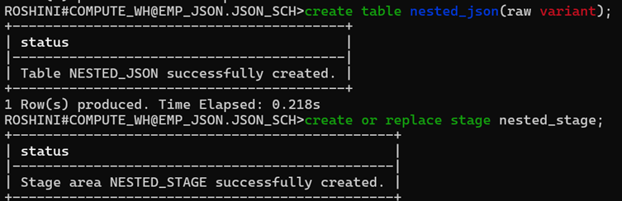

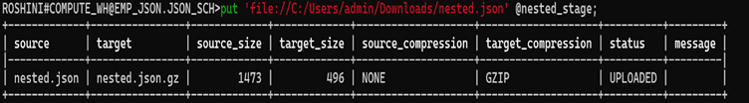
Output for Copy the data to snowflake

Step-4 create or replace file format ff_json_flat type = 'JSON' strip_outer_array = false;
Step-5 copy into nested_json from @nested_stage/nested.json file_format = (format_name = 'ff_json_flat');
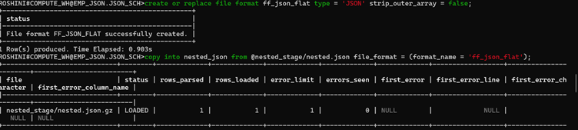
Output for file_format and copy into snowsql

Step-6 select*from nested_json:
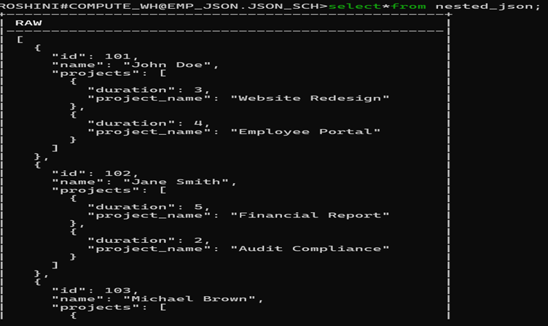

Select raw:id::int as id,
Raw:name::string as dept from nesed_json:
Output:
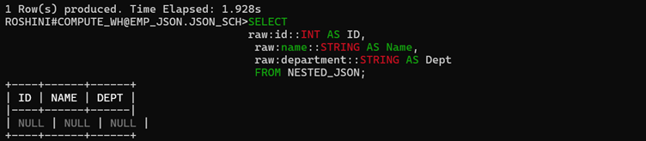
In this part i got null records because of my json path is wrong.After i checked and give right json path it will come like this.

For right query in nested_json:

Select emp.value:id::INT AS Employee_ID,
emp.value:name::STRING AS Employee_Name,
proj.value:project_name::STRING AS Project_Name,
proj.value:duration::INT AS Duration
FROM NESTED_JSON,
LATERAL FLATTEN(input => raw) emp, -- first flatten employees
LATERAL FLATTEN(input => emp.value:projects) proj; -- second flatten projects

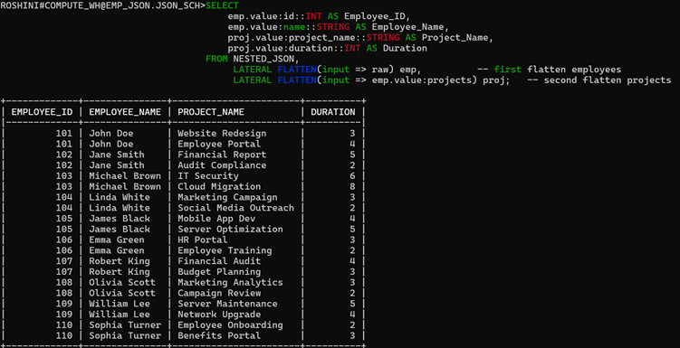
Output for select query in nested_json

XML-SIMPLE
steps:

step-1 CREATE OR REPLACE TABLE xml_table (id
INTEGER AUTOINCREMENT,xml_doc VARIANT);
Step-2 create or replace stage xml_stages;
Step-3 put 'file://C:/Users/admin/Downloads/employees.xml' @xml_stages;
output:
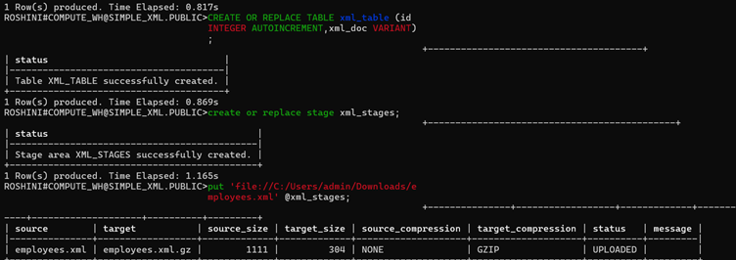
Step-4 CREATE OR REPLACE FILE FORMAT my_xml_format TYPE = 'XML'STRIP_OUTER_ELEMENT = TRUE COMPRESSION = 'AUTO';
Step-5 Copy into xml_table(xml_doc)from @xml_stages/employees.xml file_format = (format_name = 'my_xml_format');

Output:

Step-6 select * from xml_table;

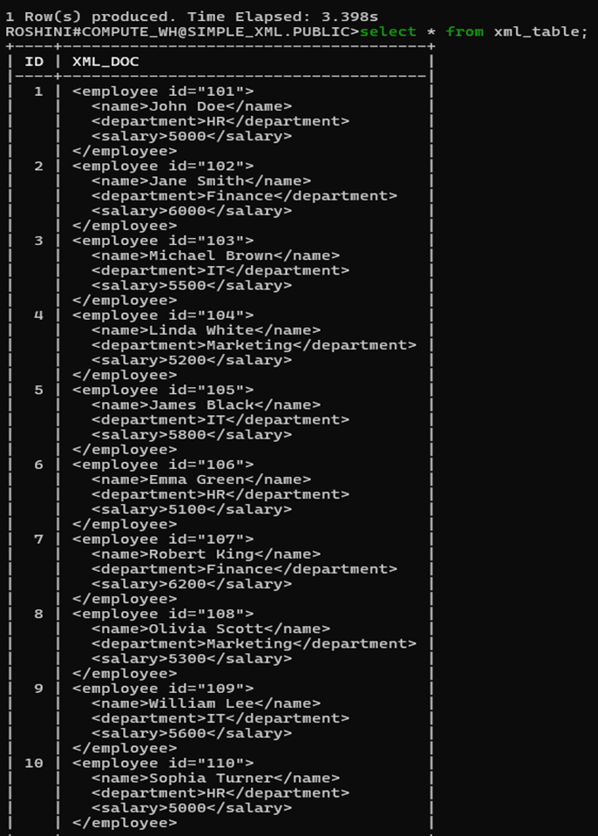

Step-7 CREATE OR REPLACE TABLE EMPLOYEES_FINAL (ID INT,NAME STRING,DEPARTMENT STRING,SALARY INT);
Output:
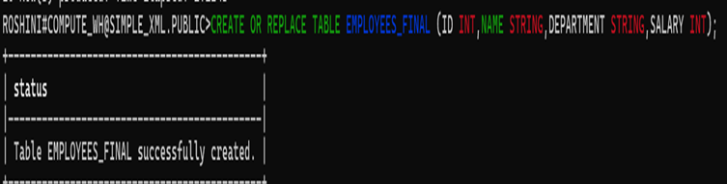

Step-8 INSERT INTO EMPLOYEES_FINAL (ID, NAME, DEPARTMENT, SALARY)
SELECT
XML_DOC:"@id"::string::int AS ID,
XMLGET(XML_DOC, 'name'):"$"::string AS NAME,
XMLGET(XML_DOC,'department'):"$"::string AS DEPARTMENT,
XMLGET(XML_DOC,'salary'):"$"::int AS SALARY
FROM XML_TABLE;

Step-9 SELECT * FROM EMPLOYEES_FINAL;

Output:
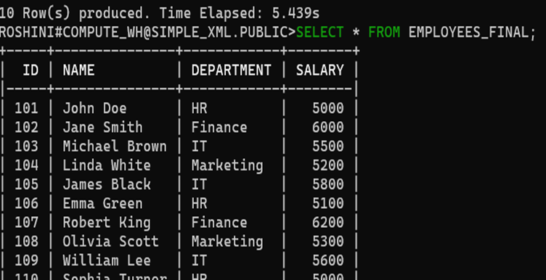
XML - NESTED

Steps:

Step-1 create database nest_xml;

Step-2 create schema nest_schema;

step-3 CREATE OR REPLACE TABLE xml_table (id INTEGER AUTOINCREMENT,xml_doc VARIANT);

Step-4 create or replace stage xml_stage;

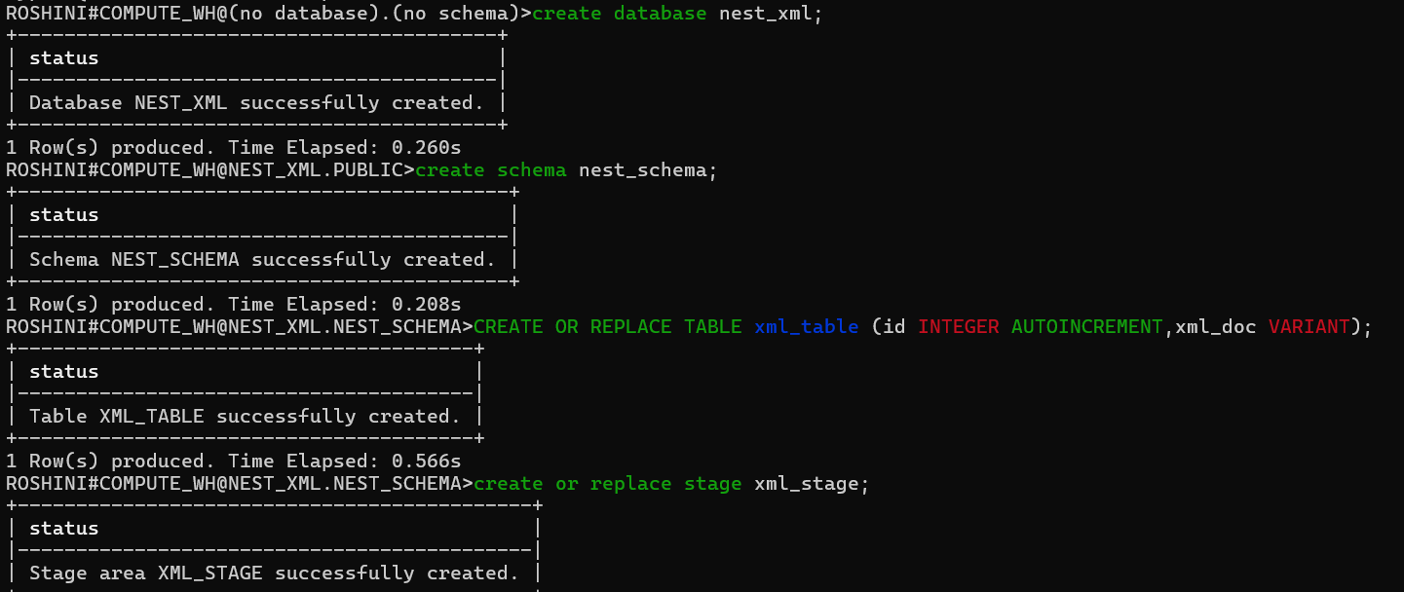

Step-5 put'file://C:/Users/admin/Downloads/emp_project.xml' @xml_stage;

Step-6 CREATE OR REPLACE FILE FORMAT my_xml_format TYPE = 'XML'STRIP_OUTER_ELEMENT = TRUE COMPRESSION = 'AUTO';

Step-7 Copy into xml_table(xml_doc)from @xml_stage/emp_project.xml file_format = (format_name = 'my_xml_format');
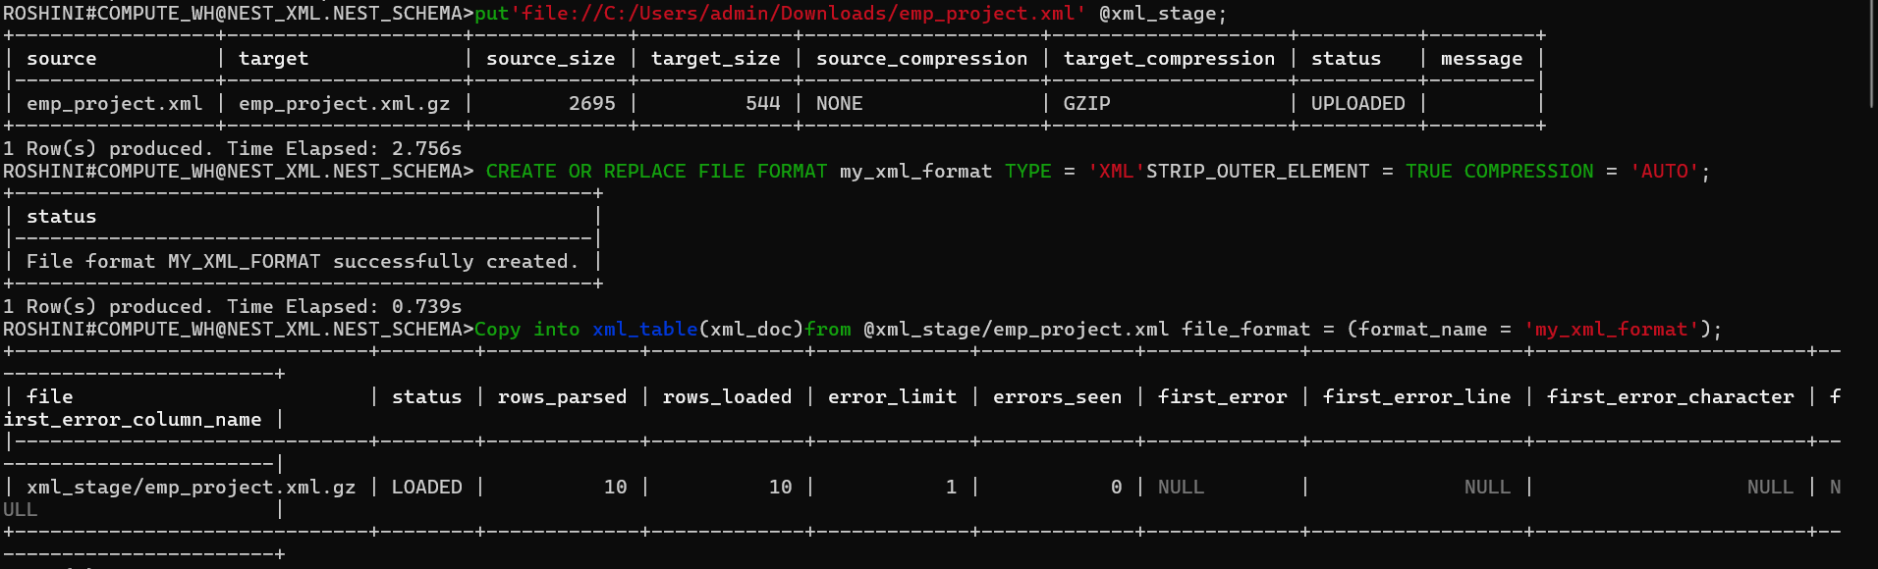
Step-8 select*from xml_table;

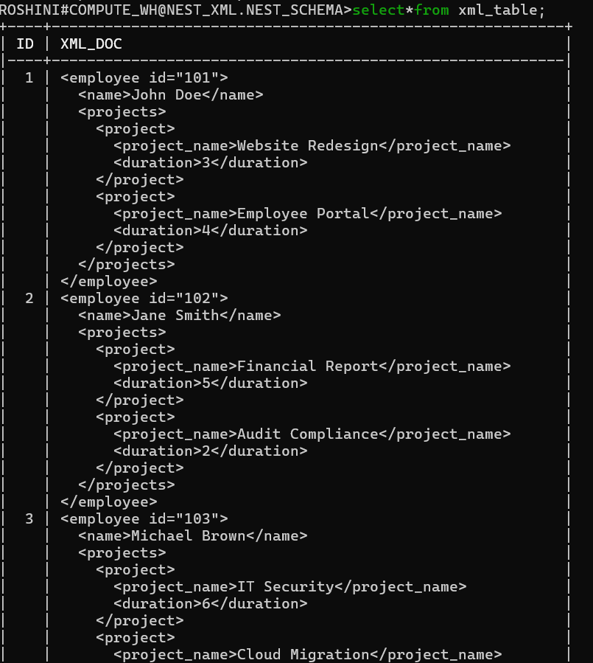

Step-9 create or replace table employee_projects_final(emp_id int,emp_name string,project_name string,duration int);

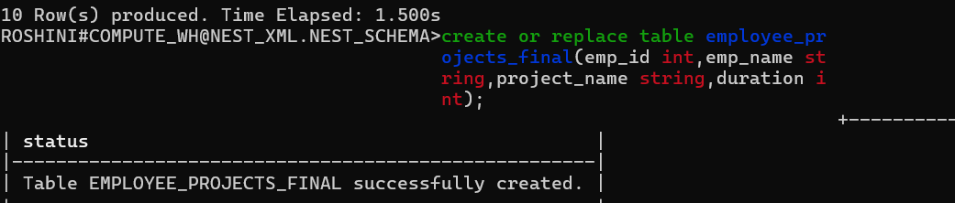

Step-10 INSERT INTO EMPLOYEE_PROJECTS_FINAL (EMP_ID, EMP_NAME, PROJECT_NAME, DURATION)
SELECT XML_DOC:"@id"::int AS EMP_ID,
XMLGET(XML_DOC,'name'):"$"::string AS EMP_NAME,
XMLGET(XML_DOC,'project_name'):"$"::string AS PROJECT_NAME,
XMLGET(XML_DOC, 'duration'):"$"::int AS DURATION FROM XML_TABLE;

Step-11 Select*from EMPLOYEE_PROJECTS_FINAL;

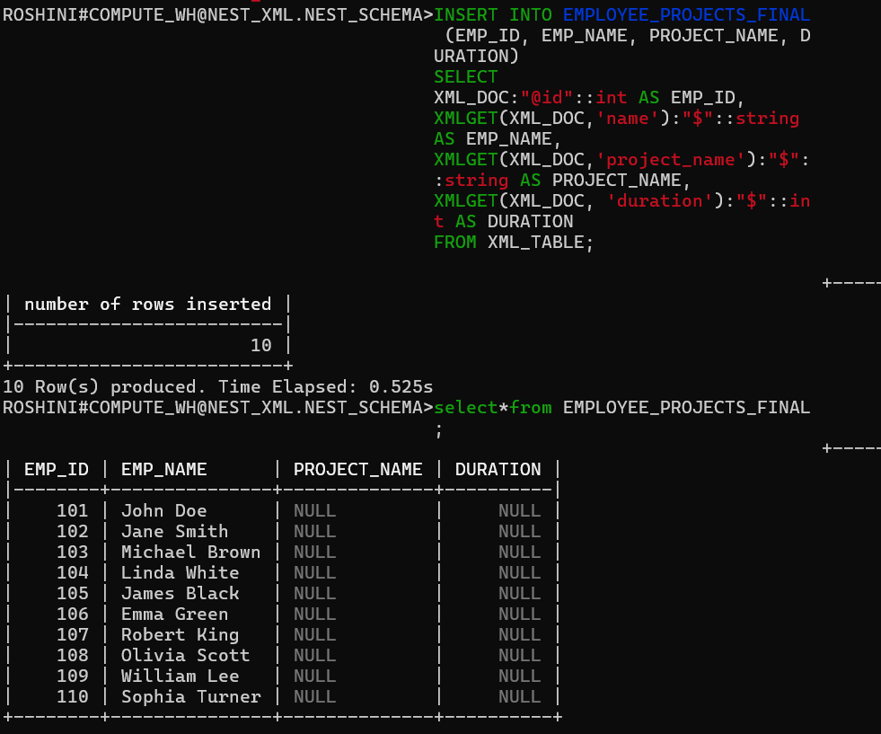
Through i tried lateral flatten i got same null values.
SELECT
XML_DOC:"@id"::int AS EMP_ID,
XML_DOC:"name"::string AS EMP_NAME,
project.value:"project_name"::string AS PROJECT_NAME,
project.value:"duration"::int AS DURATION
FROM XML_TABLE,
LATERAL FLATTEN(input => XML_DOC:"projects"."project") project;

